|| जय श्री राम ||
Salesforce Development
Apex is a programming language used in salesforce for backend development
- It is similar to Java—apex is also a object oriented programming language(classes, interfaces, abstraction).
- Java you can take input and print output in CMD but in apex we can’t take input form cmd, need to go to UI.
DATA TYPES IN APEX
- Integer-32 bit
- Long-64 bit
- Decimal -for precise calculations for eg. currency
- Double – after point 8 digits allowed
- String – no datatype for character
- Boolean – true/false
- Date – used to store only date
- Time
- Datetime
- ID - used to store 18/15 digit record ID.
COLLECTION
- List<T> - like Array in java, ordered collection
- Set<T> - unordered list, contains only unique values
- Map<K,V> - key-value pair, key is always unique. Collection is not allowed at Key side but allowed in Value in side.
Apex Dev:
Salesforce->Setting icon->Developer console-everything can be written except LWC

- Class & Method name should be camel case (first letter, first word small)
- PUBLIC class- can be accessed outside class but within the same package.
- Private class – can be accessed within the same class only.
- Protected class – can be accessed within same class and child class
- Global class – you are able to access class, variable outside the package also.
There is no main method in apex, so we have to define execution too ( no predefined format for execution).
Static keyword- used to avoid creating of instance of the class to used that method.
Return type- like void, int etc.
Method name.
Conditional Operator:
- IF
- Else if
- Else
System.debug('Invalid operator');--for developer purpose only.
Ctrl+S for save -> Ctrl+E (execution window) (Debug)-> Write class+dot+method->Execute->Doubel click on log-> check Debug only
Inside Log – able to find doubt, each and every line what every line has executed
There is no % for remainder, alternatively we have:
- else if(operator =='%'){
- System.debug(Math.mod(Num1, Num2));
- }
Switch Statement:

Loops:
- For loop
- While loop
- Do-while loop
- For-each-loop(Enhanced)

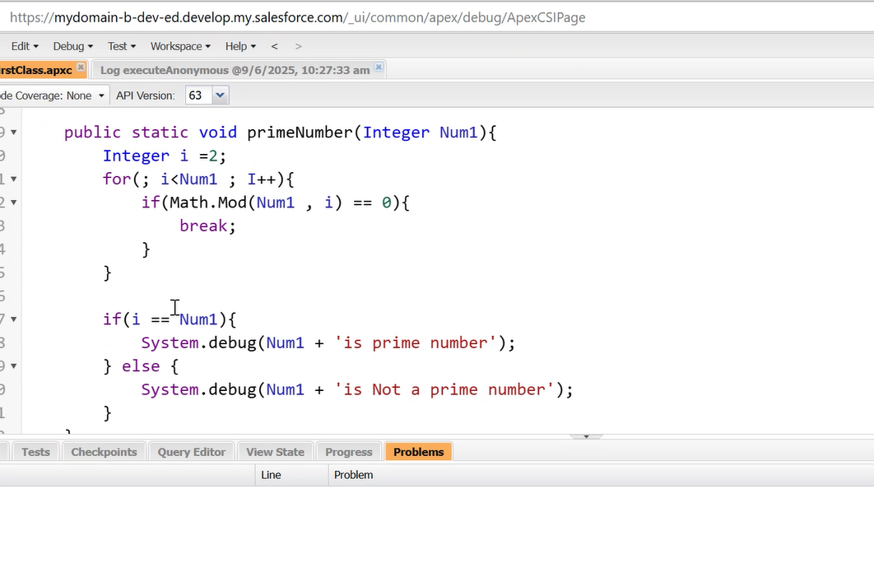

Write a program FOR FIBONACCI NUMBER from 1 to N.
FOR Armstrong number
For finding square root of number without using Math() function
For finding prime numbers between 1 to N.

LIST

List<Integer> list = new List<Integer>();
list.add(10);
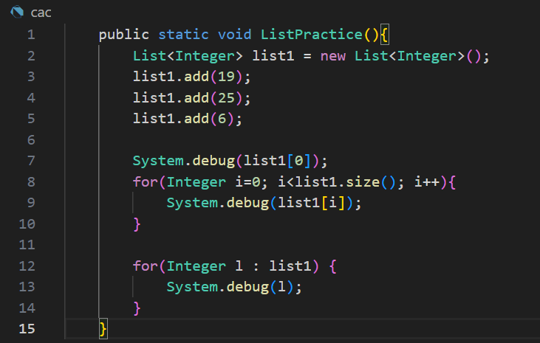

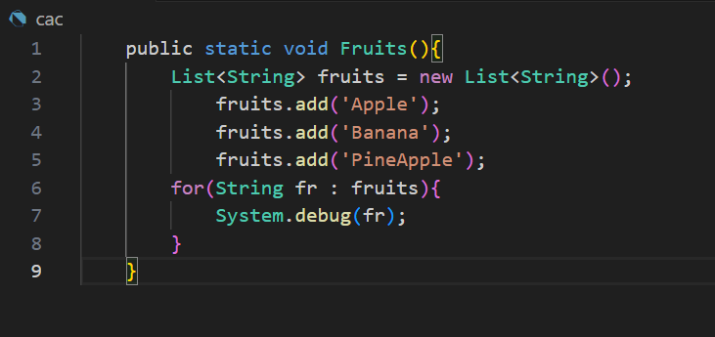
SET
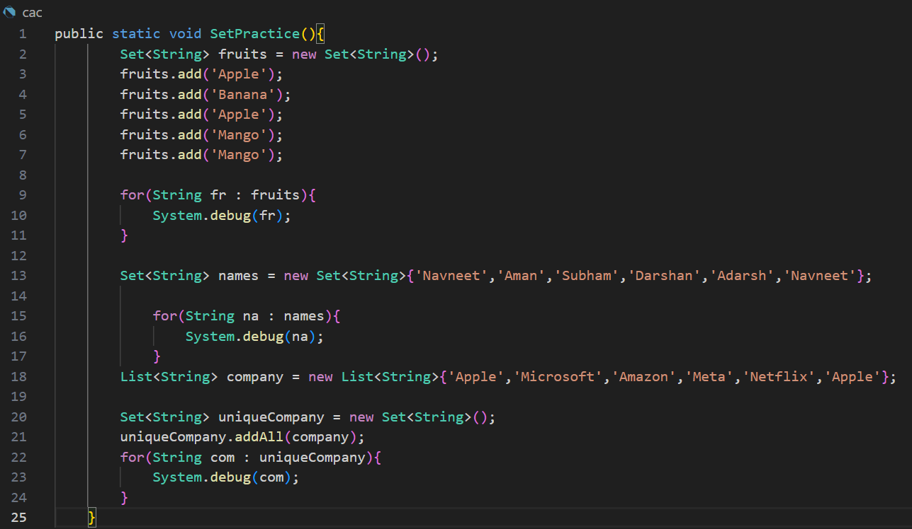
List inside list:
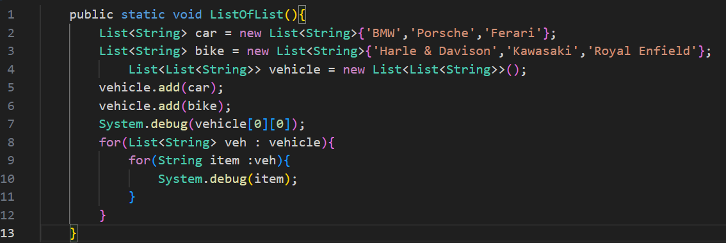
Set Inside List
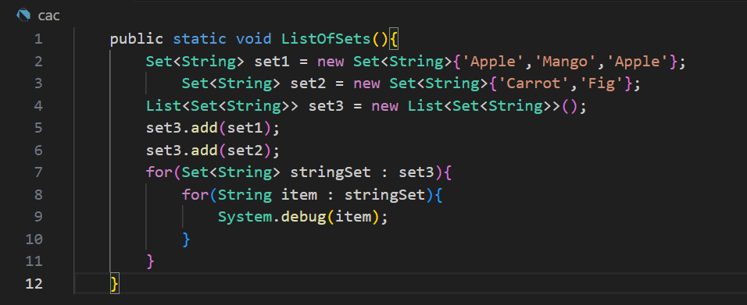s
MAP
Map<Integer, String> map1 = new Map< Integer, String >();
map.put(1,’Navneet’);
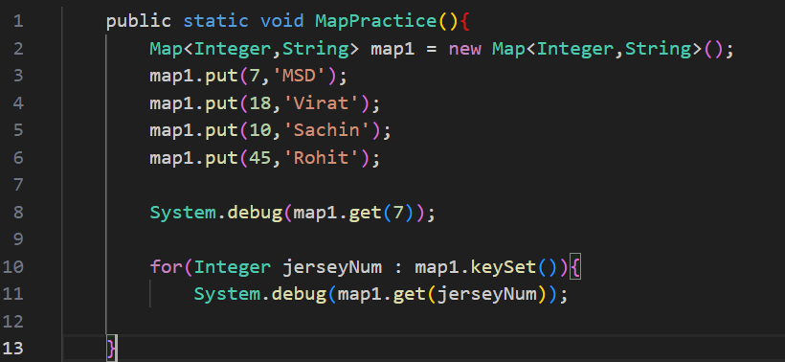
State wise city
Map<String, List<String>> map1 = new
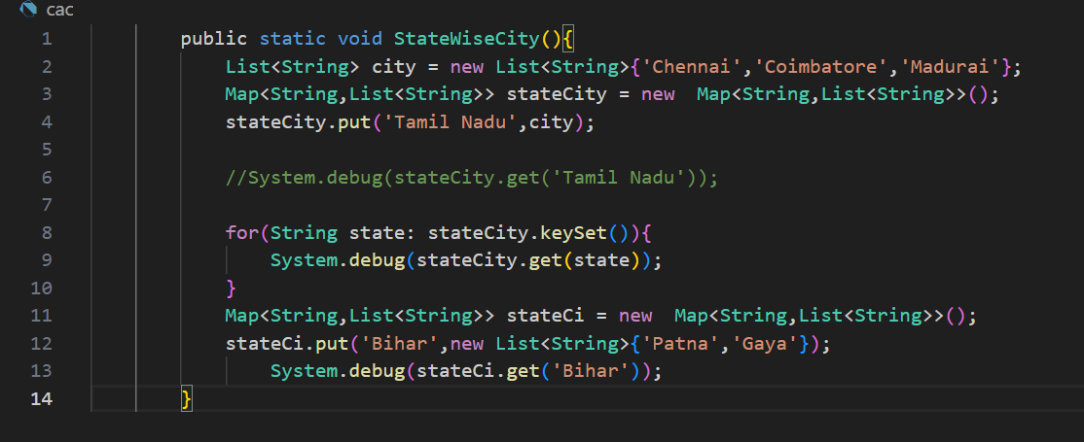
Country wise state wise city:
Map<String, Map<String,List<String>>>
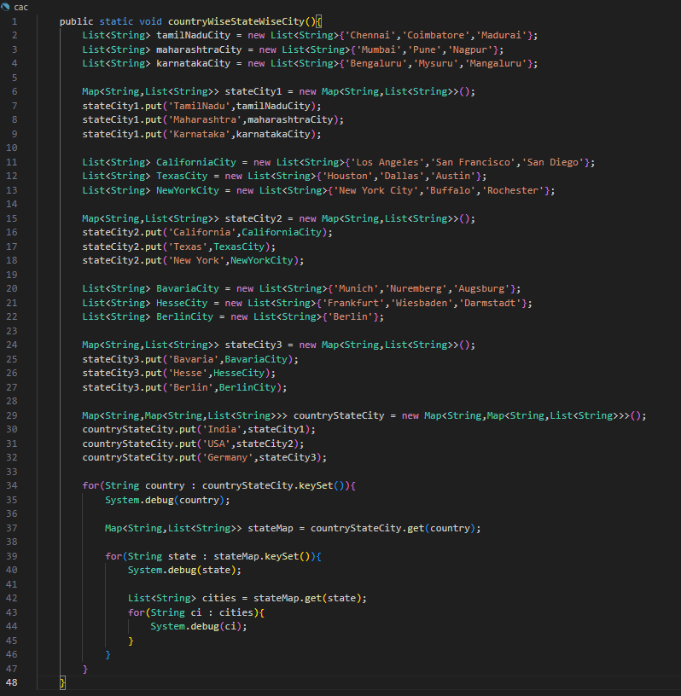
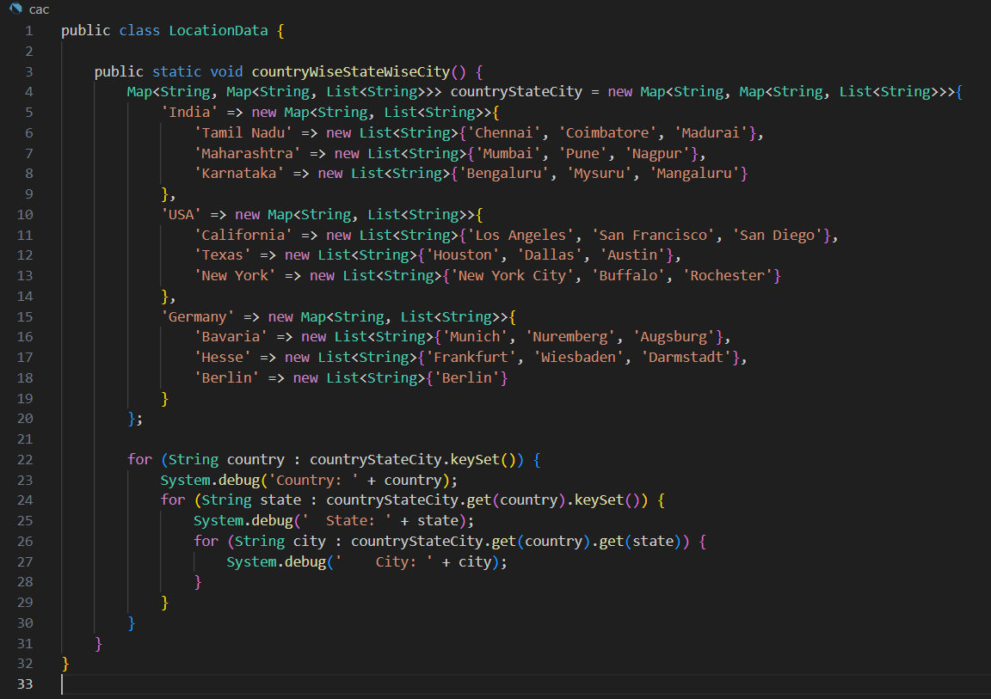
Practice Questions
Map<string,list<id>> map2 = new Map<string,list<id>>();
Map<string,list<list<string>>> map3 = new Map<string,list<list<string>>>();
Map<string,list<Map<string,boolean>>> map4 = new Map<string,list<Map<string,boolean>>>();
Map<string,list<Map<string,list<string>>>> map5 = new Map<string,list<Map<string,list<string>>>>();
Map<string,list<Map<string,list<Map<string,list<string>>>>>> map6 = new Map<string,list<Map<string,list<Map<string,list<string>>>>>>();
this are the 6 collection format i am sharing you have to fill detail in this collection and then iterate using loop for each one of them
SOQL
- Salesforce Object Query language.
- (* ) doesn’t work, need to write all field
- Only API name should be used—no option(why? & how)
- One more datatype called sObject
Syntax:
SELECT field1, field2 FROM ObjectName WHERE condition
SELECT Id, Rating, Name, Industry, DOB__C FROM Account
If using inside apex class:---
List<Account> list = [select id, name from account];
When you don’t know specific object:
List<sObject> list = [select id, name from account];
If using custom object then object API Name should be used.
How to access each record of the List which created: - using iteration
for(Account acc : list){
System.debug(acc.name);
System.debug(acc.rating);
System.debug(acc.id);
}
For any specific type:
select id, name, rating from account where rating ='hot'
SELECT Id, Name, Rating, Industry
FROM Account
WHERE Rating = 'Hot' AND Industry = 'Banking'

Sort queries:
- ORDER BY (BY Default ascending)
- SELECT Id, Name, Rating, Industry
- FROM Account
- WHERE Rating = 'Hot' AND Industry = 'Banking'
- ORDER BY Name ASC

SELECT Id, Name, Rating, Industry
FROM Account
WHERE Rating = 'Hot' AND Industry = 'Banking'
ORDER BY Name DESC

Sort by multiple fields:

SELECT Id, Name, Rating, Industry
FROM Account
WHERE Rating = 'Hot' AND Industry = 'Banking'
ORDER BY Industry, Name DESC

Offset & Limit
SELECT Id, Name, Rating, Industry
FROM Account
WHERE Rating = 'Hot' AND Industry = 'Banking'
ORDER BY Name
LIMIT 10
OFFSET 5

GROUP BY

List<Contact> list = [SELECT Id, count(Id), LastName From contact Group By AccountId]; ---wrong

SELECT AccountId, COUNT(Id)
FROM Contact
GROUP BY AccountId
In apex class Aggregate Result datatype should be used as count does not have datatype.

List<Aggregate Result> list = [SELECT AccountId, COUNT(Id) CountContact
FROM Contact
GROUP BY AccountId
];

IMP: here comes the alias name as count field need to be accessed as CountContact

For(Aggregate Result ar : list) {
System.debug(ar.get(‘AccountId’);
System.debug(ar.get(‘CountContact’);
}

HAVING
CHILD TO PARENT & PARENT TO CHILD
List<Contact> list = [SELECT Id, LastName, email, Account.Name, Account.Rating, Account.website FROM Contact];
If the parent object is custom then related object is used College__r.Rating
List<Contact> list = [SELECT Id, LastName, email, Account.Name, College__r.Rating, Account.website FROM Student__c];
From parent to child we need subqueries:--from here we can get Child Relationship Name
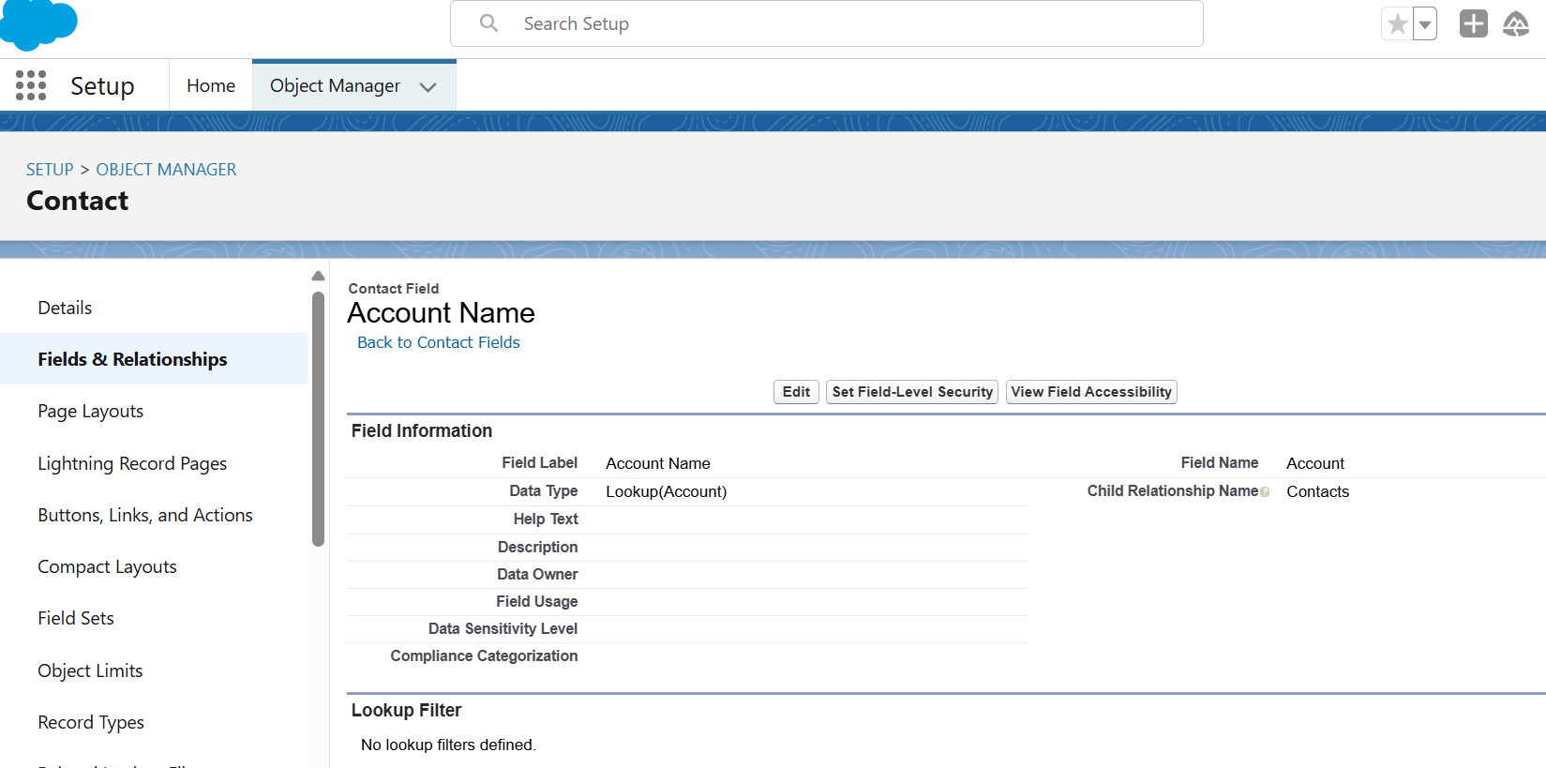
List<Account> list = [SELECT Id, Name,(SELECT Id, LastName, email, Phone, Salutation FROM Contacts) FROM Account ];
If in parent to child your using custom field you have to use child relationship as Name+__r .

1. Write a SOQL to fetch all account records which are created today
2.Write a SOQL to fetch all opportunity records which are closed this month
3.Write a SOQL to fetch all opportunity records which are created in last year
5Write a SOQL to fetch all Users whose profile is System Admin
6. Write a SOQL to fetch 10 recently accessed Account record
7. Write a SOQL to fetch Tasks that are assinged on a Particular Account
1.Write a SOQL to Sum(amount),MAX(Amount),MIN(Amount),AVG(Amount) from the opportunity

Q-Write a method that collects Rating as a parameter , according to Rating fetch Account records and print the details of that Account record.

SOSL
Salesforce Object Search Language

Find {____} in ALL Fields Returning Account (Id, Name, Annual Revenue WHERE Industry = ‘Banking’)

Keywords:
ALL fields
Name Fields
Phone Fields
Email Fields

Working with multiple object:-you can search on two objects even though they are not related to each other in any way

Find {____} in ALL Fields Returning Account (Id, Name, Annual Revenue WHERE Industry = ‘Banking’), College__c(Id, Name ), Books__c(Id, Name )

In apex:

List<List<sObject>> list1 = [ Find ‘string’ in ALL Fields Returning Account (Id, Name, Annual Revenue WHERE Industry = ‘Banking’), College__c(Id, Name ), Books__c(Id, Name ) ] ----According to copilot SOSL does not support filtering like WHERE , it should be done in apex code
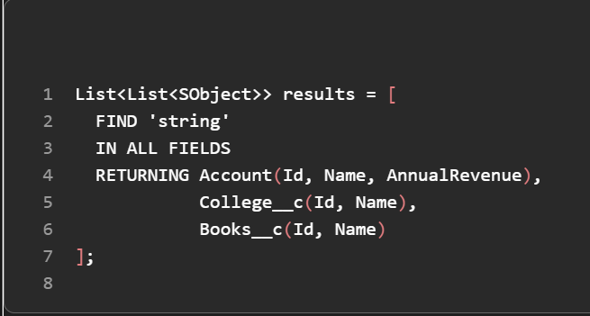
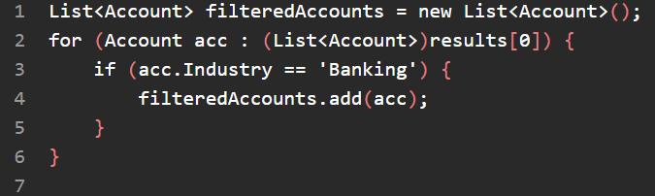

Questions: 1
2. Write SOSL to search for keyword Satish Myla in all fields

List<List<sObject>> list1 = [FIND ‘Satish Myla’ IN ALL FIELDS ];
3.Write SOSL to search for '1234' in Phone fields
List<List<sObject>> list1= [FIND ‘1234’ IN PHONE FIELD];

4.Write SOSL to Search for ' javasfdc@gmail.com' in all the email fields
List<List<sObject>> list1 = [FIND ‘javasfdc@gmail.com' IN EMAIL FIELD];
retrieve all accounts that have contacts who have logged a case in the last 30 days
find the top 5 accounts with the highest number of opportunities in the 'Closed Won' stage
retrieve all accounts that have more than 3 contacts and at least one opportunity in the 'Prospecting' stage
find all opportunities where the related account’s industry is 'Technology' and the opportunity amount is greater than $100,000
retrieve the 10 most recently created leads from the 'Web' source
find all cases that were closed in the last fiscal quarter and group them by priority

search for the term "urgent" in the subject of cases and the description of tasks
search for contacts whose email starts with "john" and return only the first 5 results
search for a keyword across both standard objects (like Account, Contact) and a custom object (e.g., Project__c)

DML
- Data Manipulation language
- Insert, Update, Delete, Undelete
Public static void dmlStatement(){
Account acc = new Account();
acc.Name = ‘Testing’;
acc.Rating = ‘Hot’;
acc.Industry = ‘Banking’;
Insert acc;
}
Governor limits
Do not write any SOQL, SOSL, DML inside loop;

To create multiple records:
List<Account> accList = new List<Account>();
// Account acc = new Account();
for(int i=0; i<5;i++){
Account acc = new Account();
acc.Name = ‘Testing’+i;
acc.Rating = ‘Hot’;
acc.Industry = ‘Banking’;
accList.add(acc);
}
Insert accList;

--To add

List<Account> accList = [SELECT Id from Account WHERE Rating = ‘Hot’];
List<Contact> conList = List<Contact>();
for(Account acc : accList){
Contact con = new Contact();
Con.lastName = ‘Testing’;
con.accountId = acc.Id;
conList.add(con);
}
Insert accList;

Update:

Contact con = new Contact();
con.Phone =’34567895687’;
con.email =’abc@gmail.com’;
con.Salutation =’Mrs.’;
con.Id = ‘’; // it is most important—record id
update con;

List<opportunity> oppList = [SELECT id, closedDate from opportunity WHERE stageName = ‘Closed Won’ OR StageName = ‘Closed Lost’];
for(opportunity opp : oppList){
opp.closedDate = System.today();
}
Update oppList;

Delete :
- Like update here ID is required- without that record can not be deleted
- Standard records can’t be deleted.

Public static void dmlStatement(){
Account acc = new Account();
Acc.Id = ‘____’;
Delete acc;
}

Delete those records on which Account name start with ‘a’:
List<Account> accList = [SELECT Id From Account WHERE Name LIKE ‘A%’];
Delete accList;

Undelete:
- Only deleted record can be undeleted.
- For every object standard field isDeleted is there
- You must use ALL ROWS in your SOQL query to access soft-deleted records
List<Account> accList = [SELECT Id FROM Account WHERE isDeleted = True ALL ROWS];
Undelete accList;

Exception Handling:
- Try—code is written on which it is possibility of getting runtime errror
- Catch--
- Finally—it run in all cases whether you get exception or not

Try{
System.debug(100/0);
}catch( Mathexception e){
System.debug(e.getMessage());
}finally{

}
How to throw custom error:----using try{} block

Try{
If(){
Throw new customException(‘there is a validation error’);
}
}catch(Mathexception e){
System.debug(e.getMessage());

Trigger
Insert
Update
Delete
Undelete

- Similar to record-triggered flow—advanced version
- Syntax from apex only
- When to use trigger:
- Before & After—before used when data is not saving to the database and opposite for after
- Before Insert and After Insert
- Before Update and After Update
- Before Delete and After Delete
- But only After Undelete---bcz before means it is in pipeline

Write a trigger whenever a Account record is created
- In before insert we do not have recordId available, but after insert we have recordId. But in case of Undelete we have recordId everywhere RecycleBin, pipeline and database.

Context variables—especially used for apex triggers
- Trigger.new List<sObject>
- Trigger.newMap Map<Id,sObject>
- Trigger.old List<sObject>
- Trigger.oldMap Map<Id,sObject>

 | Trigger.new | Trigger.newMap | Trigger.old | Trigger.oldMap
Before Insert | y | n | n | n
After Insert | y | y | n | n
Before Update | y | y | y | y
After Update | y | y | y | y
Before Delete | n | n | y | y
After Delete | n | n | y | y
After Undelete | y | y | n | n

S-SOSL YOU are able to do
D- DML

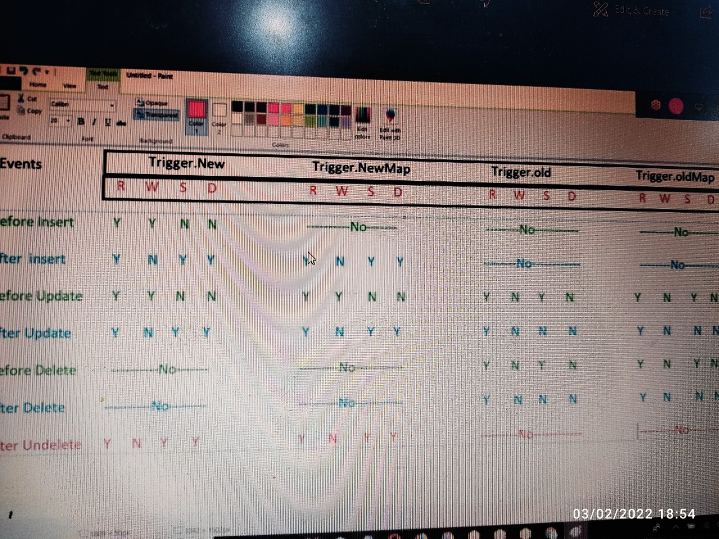

Write a trigger whenever an account is created Rating as HOT you have to update annual revenue as 50,000.

trigger SetAnnualRevenue on Account (before insert) {
for (Account acc : Trigger.new) {
if (acc.Rating == 'Hot') {
acc.AnnualRevenue = 50000;
}
}
}

Write a trigger whenever a account record is created you have to create a related contact record.

Trigger AccTrigger on Account (after Insert ) {
List<Contact> conList = new List<Contact>();
For( Id accId : trigger.newMap.keySet()) {
Contact con = new Contact();
Con.accountIdd = accId;
Con.LastName = trigger.newMap.get(accId).Name;
conList.add(con);
}
Insert conList;
}

Question:
When a new Account is inserted with Industry as banking assign the owner as 'karthic'

Whenever new Account is inserted with industry as Energy and Type as new Customer then create new Opportunity with same account data

Whenever new lead is inserted calculate the lead score based on following rules
Field Name Points(if the field values are entered)
Phone 10
Email 10
AnnualRevenue 20
Industry 20
Subject 10
Create Custom Field Number Field LeadScore . Assign the Lead score based on above fields

Important: Always think for bulk record while writing trigger

Q-Write a trigger for preventing duplicate records on Lead object on the basis of email and phone field.

trigger leadTriggerV2 on Lead (before insert) {
set<String> phone = new set<String>();
set<String> email = new set<String>();
for(Lead l:trigger.new){
phone.add(l.phone);
email.add(l.email);
}
set<String> temp = new set<String>();
List<Lead> l1 = [SELECT phone,email FROM Lead WHERE phone IN :phone AND email IN :email];
for(Lead li:l1){
temp.add(li.phone+'-'+li.Email);
}
for(Lead l:trigger.new){
if(temp.contains(l.Phone+'-'+l.email)){
l.addError('Dublicate exist');
}
else{
temp.add(l.phone+'-'+l.email);
}
}
}

Order of trigger—there is no order of execution exist
One object one trigger only
Three best practices in apex:
- Always think about bulk record
- One object, one record
- Do not write SOQL,SOSL & DML in loop

Questions:

Write a trigger, only system admin user should be able to delete the task.

---
Write a trigger on Account , when an account insert , automatically account billing address should populate into the account shipping address.

---
Create a duplicate lead when a lead in insert.

---

Two scenario:
- Whenever an Account record is created, you have to create related Contact----after insert
- Whenever an Account address is updated you have to update address on related contacts----after update

Want to write both the logic in same trigger as One Object, One Trigger

Logic for the first scenario then for the second scenario.—but need to add break using conditions ---with the help of context variables (conditional context variables)

Trigger.isDelete
Trigger.isAfter
Trigger.isInsert
Trigger.isUpdate
Trigger.isUndelete

Q- Write a trigger on Account record inserted you have to create contact record---after insert
Q- Write a trigger whenever a Account record Inserted with Rating ‘Cold’ update Annual Revenue as 50000.---before insert

Trigger helper and Trigger Handler Class—both are same only

Scenario : One object, One trigger---single object we have 5 or 10 scenario-> trigger helper class is used

Actual code is written in a separate class method---in apex code only

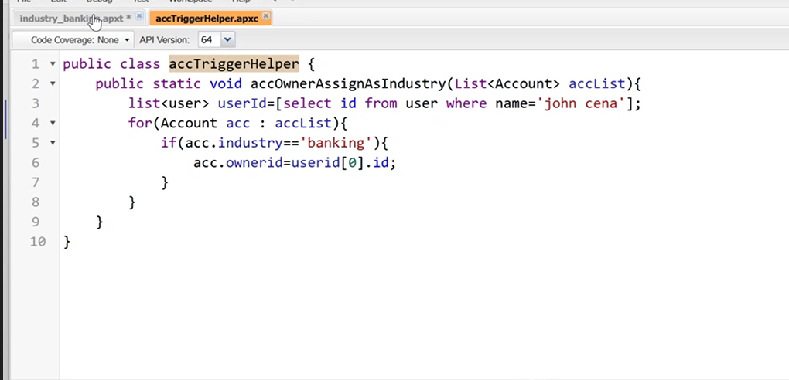

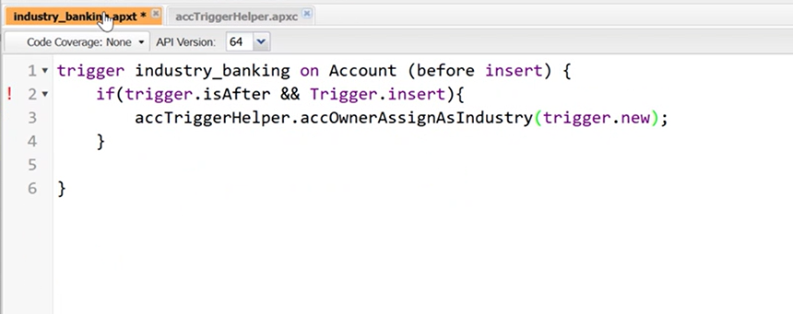

Write a trigger whenever an opportunity updated, stage name as ‘Closed Won’ or ‘Closed Lost’. You have to update the Closed Date with last day of the month.

Q- Create a duplicate lead when a lead in insert.

Recursion in Trigger
- Self Recursion—Recursion with the same trigger(same object).
- Dependent Recursion--
Trigger LeadTrigger on Lead (After Insert) {
If (trigger.isAfter && trigger.isInsert) {
If (LeadTrigger.Flag) {
LeadTriggerHandler.LeadCreation (trigger.new);
LeadTrigger.Flag = False;
}
}
}
Public class LeadTrigger {
Public static Boolean Flag = True;
Public static void LeadCreation (List<Lead> leadList) {
List<Lead> newLeadList =
}
}

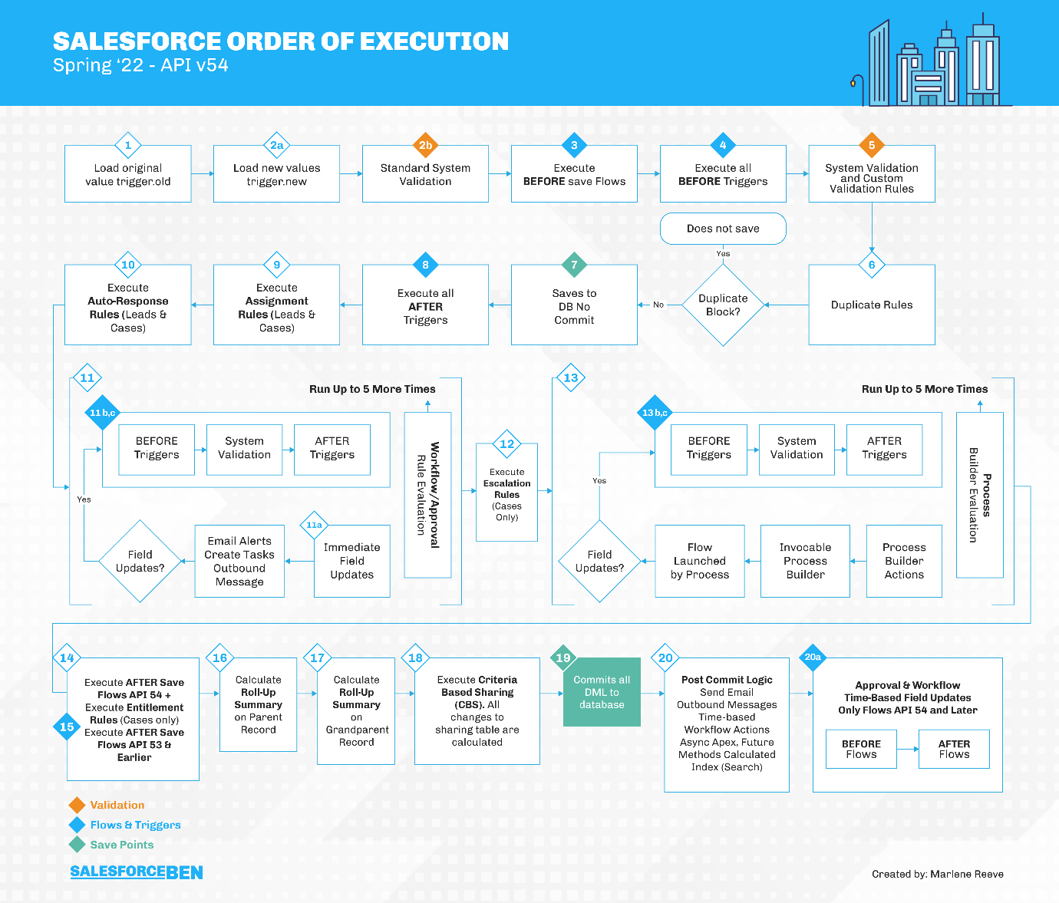

Governor limit is for per transaction.—from start of the execution to the end of the execution.
Synchronous –100 soql can be written—50000 records can be retrieved(whole transaction)—20 sosl-2000 records in a transaction-150 dml-10000 records can be processed including approval processes and recycle bin
Asynchronous- 200 soql--50000 records can be retrieved(whole transaction)

 | Synchronous Limit | Asynchronous Limit
Total number of SOQL queries issued1 | 100 | 200
Total number of records retrieved by SOQL queries | 50,000 | 50,000
Total number of records retrieved by Database.getQueryLocator | 10,000 | 10,000
Total number of SOSL queries issued | 20 | 20
Total number of records retrieved by a single SOSL query | 2,000 | 2,000
Total number of DML statements issued2 | 150 | 150
Total number of records processed as a result of DML statements, Approval.process, or database.emptyRecycleBin | 10,000 | 10,000
Total number of callouts (HTTP requests or web services calls) in a transaction | 100 | 100
Maximum cumulative timeout for all callouts (HTTP requests or Web services calls) in a transaction | 120 seconds | 120 seconds
Maximum number of Apex jobs added to the queue with System.enqueueJob | 50 | 1
Total number of sendEmail methods allowed | 10 | 10
Total heap size4 | 6 MB | 12 MB
Maximum CPU time on the Salesforce servers5 | 10,000 milliseconds | 60,000 milliseconds
Maximum execution time for each Apex transaction | 10 minutes | 10 minutes

Important:
- Class is declared and initialized, so is String as it is a class ---it has two methods---isNull (for declaration) & isBlank() for initialization as memory is allocated.
- But List can’t be declared separately, so there is only one method in List which is ---isEmpty()

Asynchronous Apex
Four types of Asynchronous apex:
- Batch—
- Schedulable
- Future
- Queueable

Batch
- particular line of code,scenario or logic, or for bulk records—chances of reaching governor limit-à with the help of batch -we can separate total records into small chunks—same code or logic can be executed in separate chunks---eg-Lead object(potential customer)—lead record will be removed and Account,Contact and Phone will be created. -à
- in business scenario, all leads will not be converted into customer, so we need to delete previous data as it can cost more

Q- Write a class for checking record date less than 30 days before today. You have to delete that record on lead object.

- Using Synchronous apex—first fetch records using SOQL, then use DML to delete—but let say data is 20,000 then for DML Governor limit will be reached.
- Interface and class concepts from java
- Access modifier should be global—reasonà
- 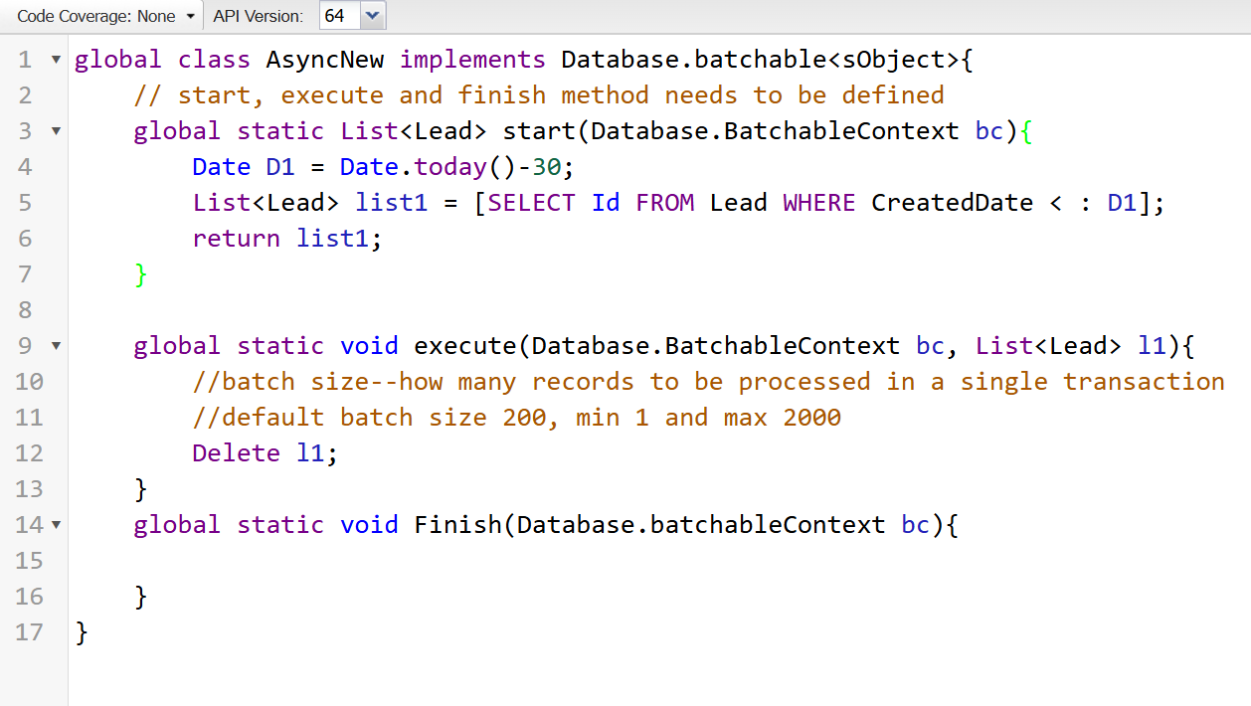
- 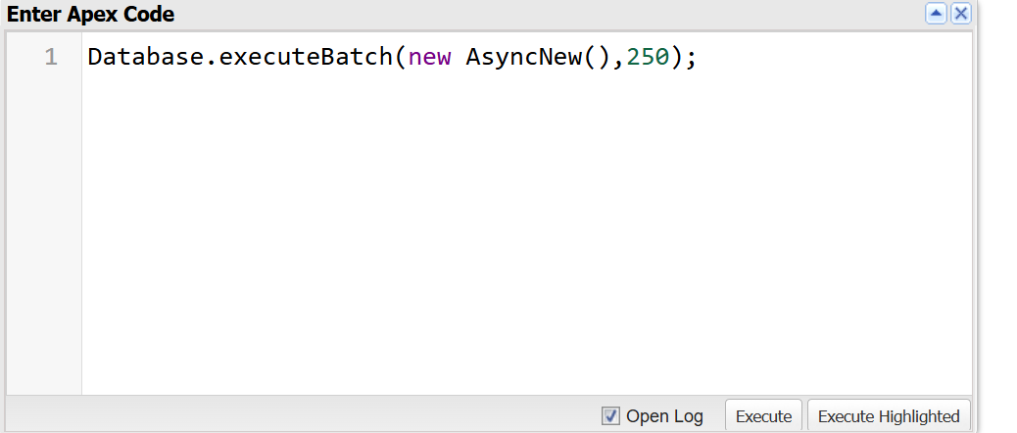

Schedualable Apex:
Q- Write an apex class where we have to find opportunity that was not modified with last N days that record we have to delete.
- Input can be taken using Constructor
- Time should be given in cron expression while running
- String S1 = ‘’—six digits separated by space, 7th is optional
- 1st value is second—(0-59)
- 2nd value is minute—(0-59)
- 3rd value is hours---(0-23)
- 4th value is Day of Month---(1-31)
- 5th value is Month---(1-12)
- 6th value is Day of Week------(1-7)(Sunday- Saturday)
- 7th value is Year—eg- 2024,2030
- *--star is defined for every
- ?—if you do not know the whichever to decide which date or month
How to check job is scheduled or not—setupàschedule jobàhere we can check and can here also we can make but have limitationsàwe can pause from here too.

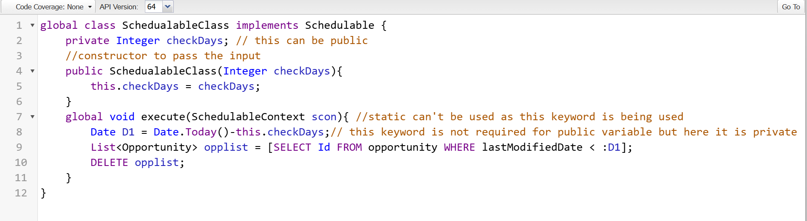

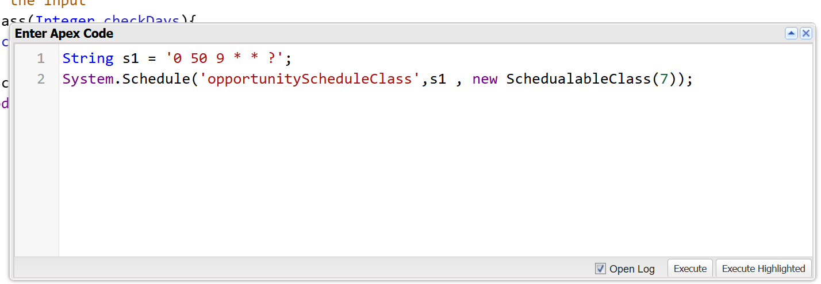

DML we can do from Database class also—not a part of Schedulable Apex
Using Database Class we can do partial update or operations but not with DML—Using BOOLEAN value
- Databse.Insert (___, FALSE )
- Databse.Delete ( )
- Database.Undelete ( )
- Database.Update ( )

More details
Queueable Apex:
- First In, First Out
- The code , the logic created by Queueable Interface decides the order of execution
- It has only method i.e. execute method
- Send email using apex
- Dynamic query
Q- Write a Queueable class where user will give you object name, on that object we have to check is there any record created within last 7 days or if not then we will send an email to system admin for informing no records created within last 7 days on the object.

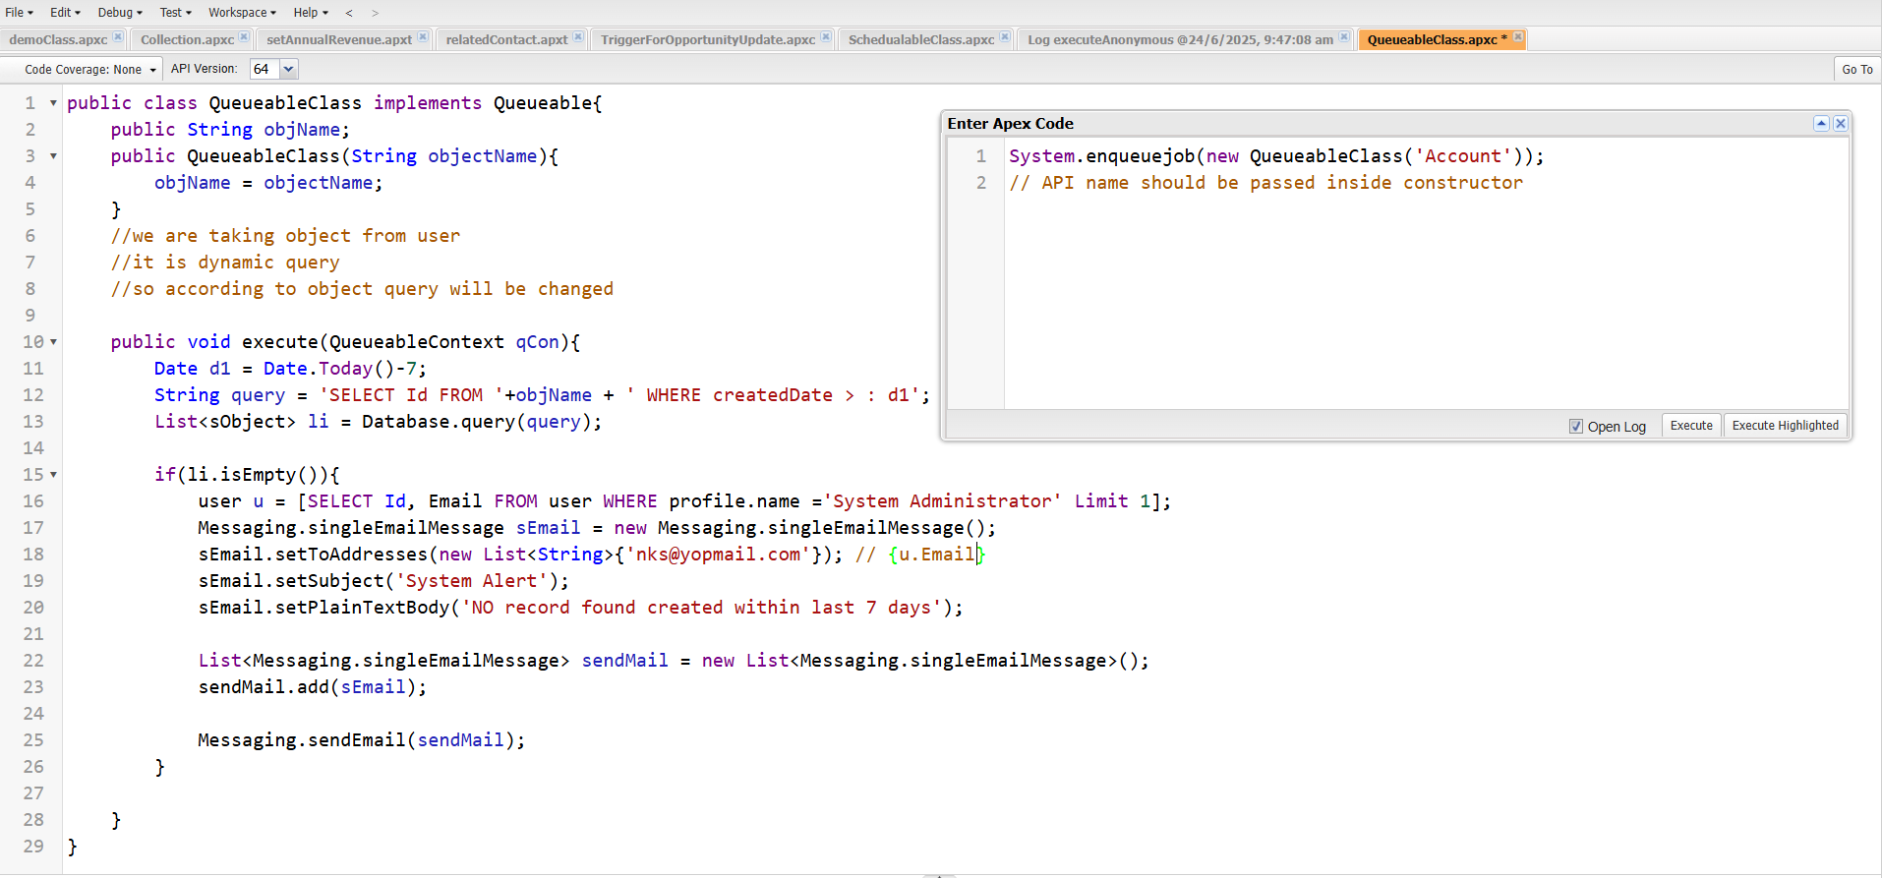

Future Apex:
- Not an interface
- Not compulsion to execute at that time, it can be executed in future
- It will execute whenever the resources are available
- If some process is under execution then it will be completed first then future method will be executed.
- Nothing can be returned from the future method as we can’t wait for the execution of future method
- Parameter can be passed which are predefined—other than that can’t be passed
- Non predefined- Aggregate Result, Database.queryLocator, HTTP request and response, wrapper class
- @Future---annotation is required
- Static method—it can be executed in normal way className.method
- All the jobs related to asynchronous job can be found from Setup->Apex Jobs.
- 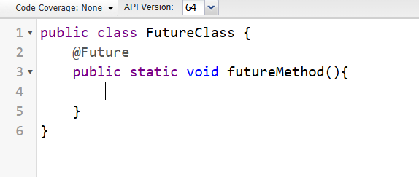

With Sharing / Without Sharing :
- By default it is without sharing if you are mentioning
- Before the class mention with sharing for record level security
- 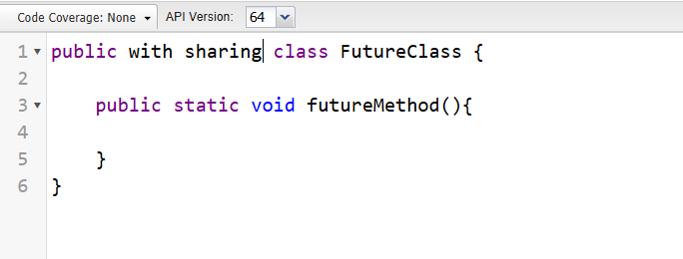
Custom label and Custom metadata:
- Setup->custom label and custom metadata
- Multiple field and records can be created---no for the use of end user but for the developer
- Used for storing internal information like employee salary etc.
- Diff between normal object and custom metadata—
Invokable Method:
- Can call class from the flows
- @invokable method to make it as
- 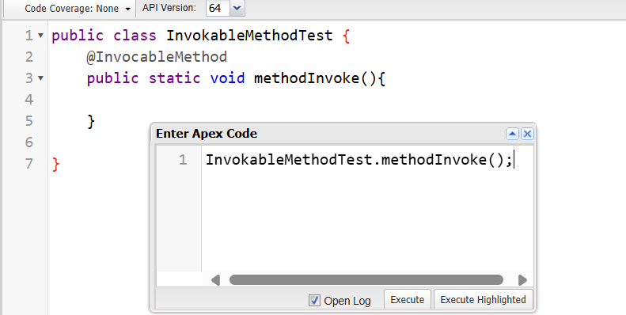
- To pass value, you need to pass collection
- If you have to pass collection then use nested collection
- In simple words always pass extra collection
- The reason we do is because it takes value from the 0th index.
- Go to flows->choose any flow then you will be able to use these in your flows.

Test Classes and Method:
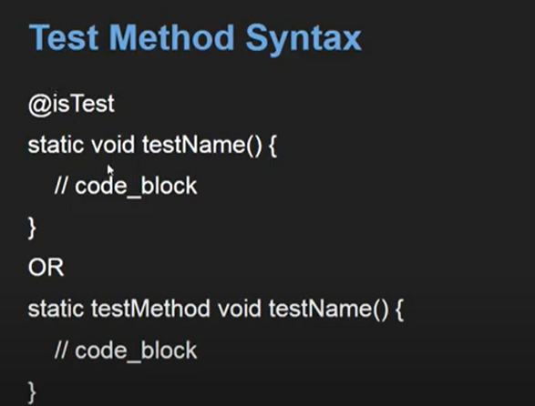

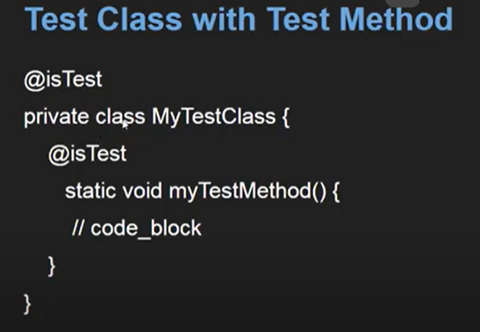

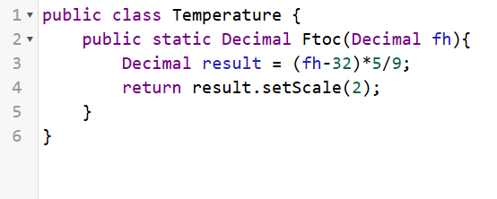

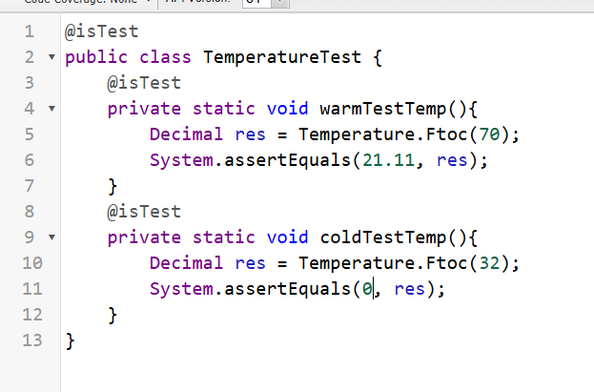

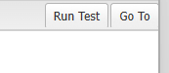

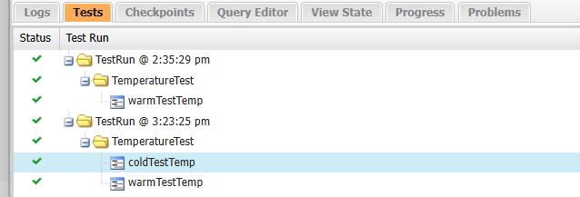

Coding
- Easy-array and sorting
- Medium – greedy,backtracking,
- Hard – DP, BST, Graph
Interview

UI
- Visual Force Pages
- Aura
- LWC

Visual Foce Page (classic UI)
- For backend :
- Standard Controller
- Controller
- Extension
Standard Controller
- Used when to work on a related object or specific object
- Specific solution or edit page for the object
- No need to write apex class
Extension
- Prebuilt page, using same page in multiple places
- Extend the functionalities of that page

VS Code in use now for UI.

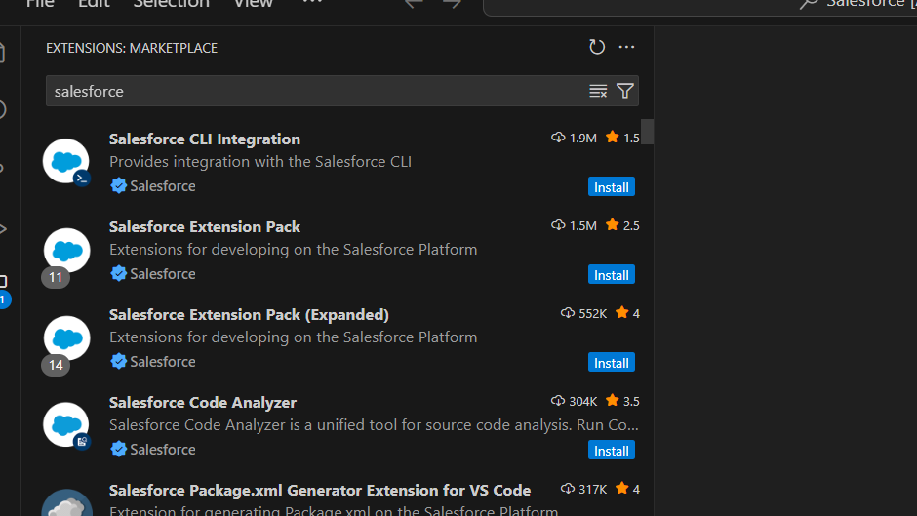

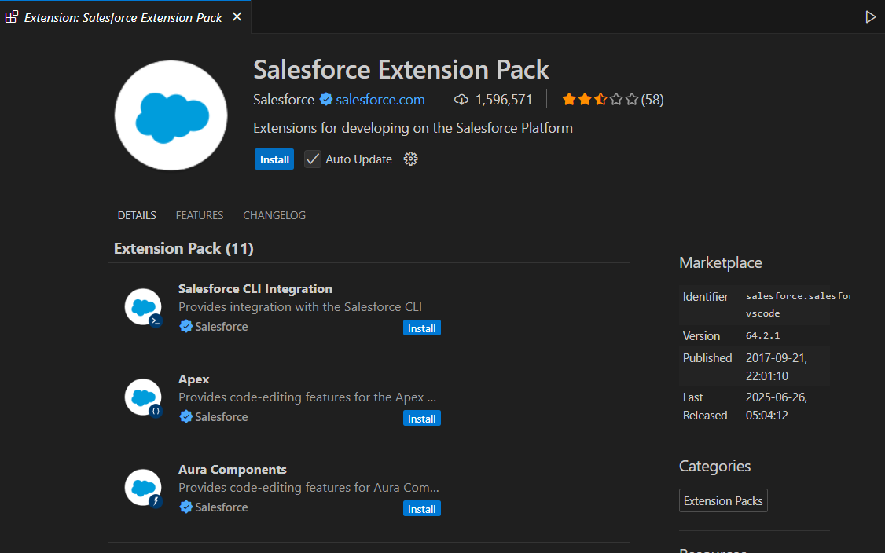

Ctrl + shift + p

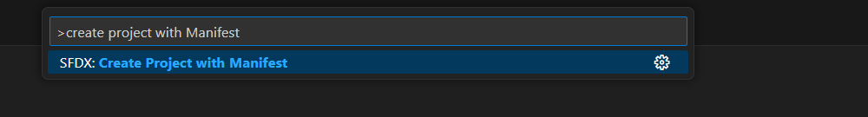

THEN STANDARD OPTION

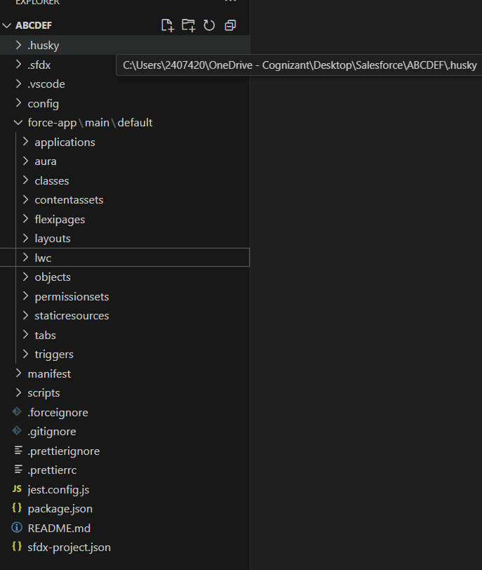

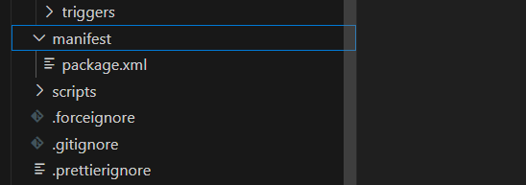

COONECT WITH SALESFORCE

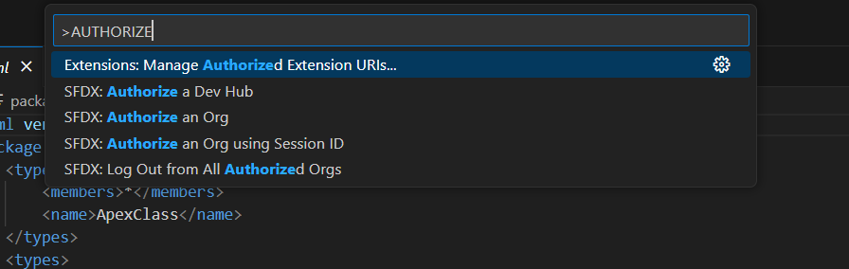
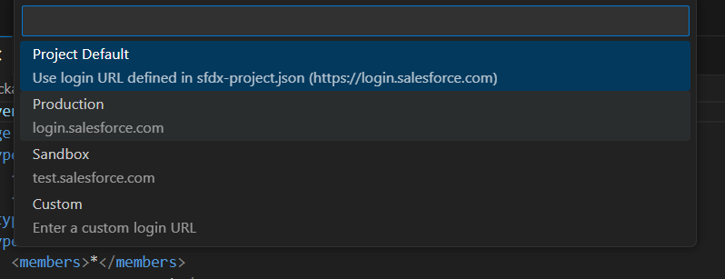

PRODUCTIONà REDIRECT TO SALESFORCE

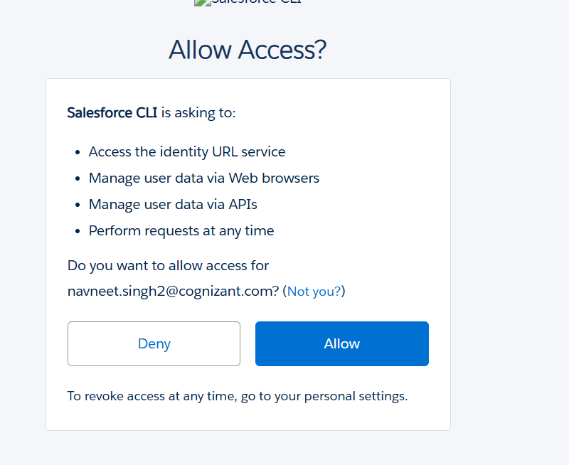

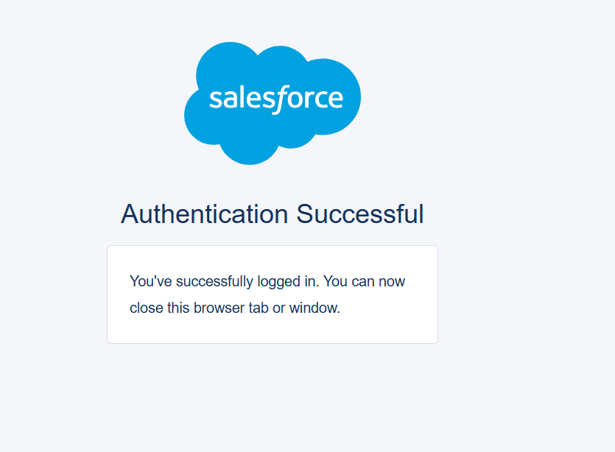
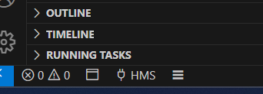

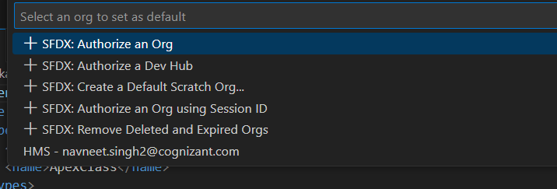

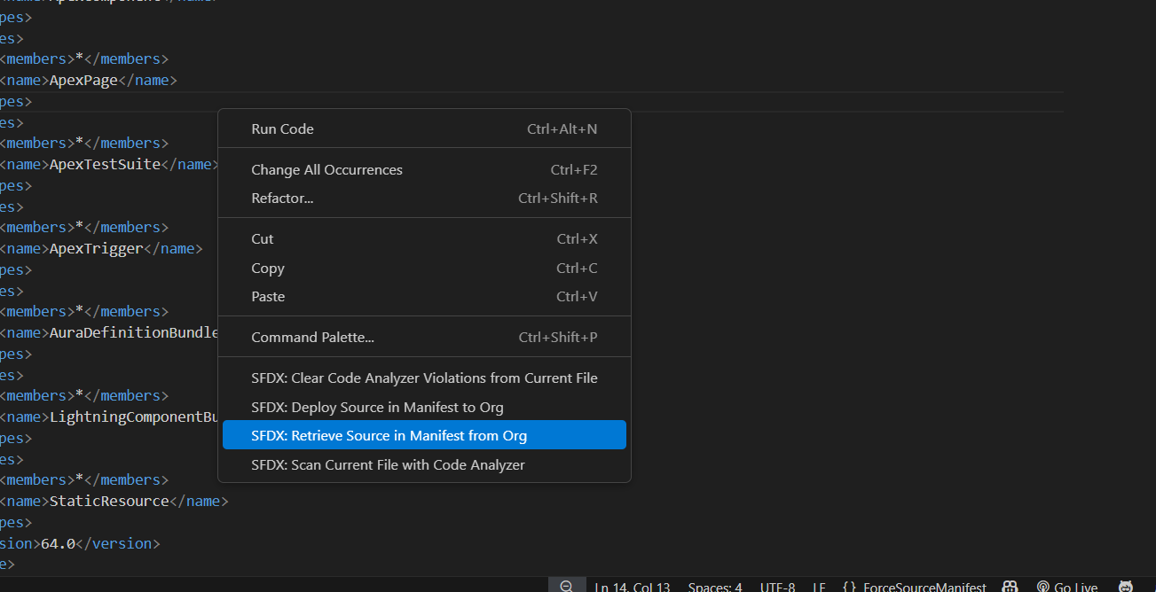

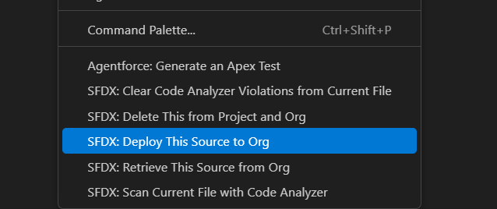

Implement Visual Force Page

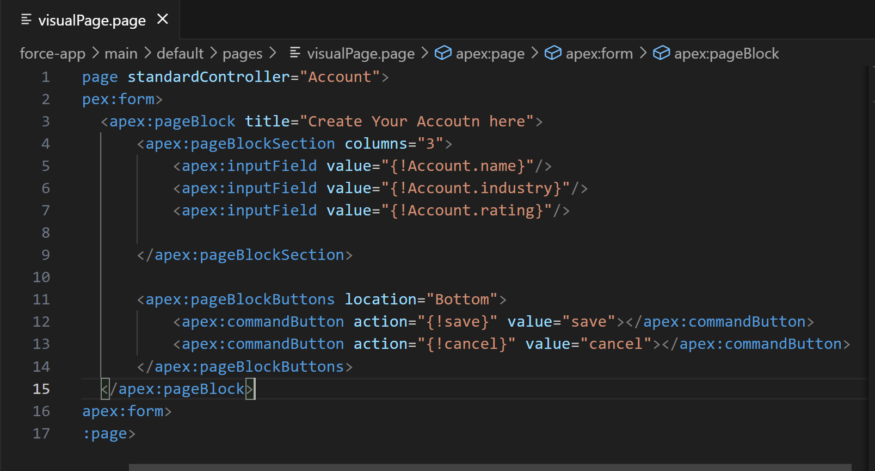

Custom

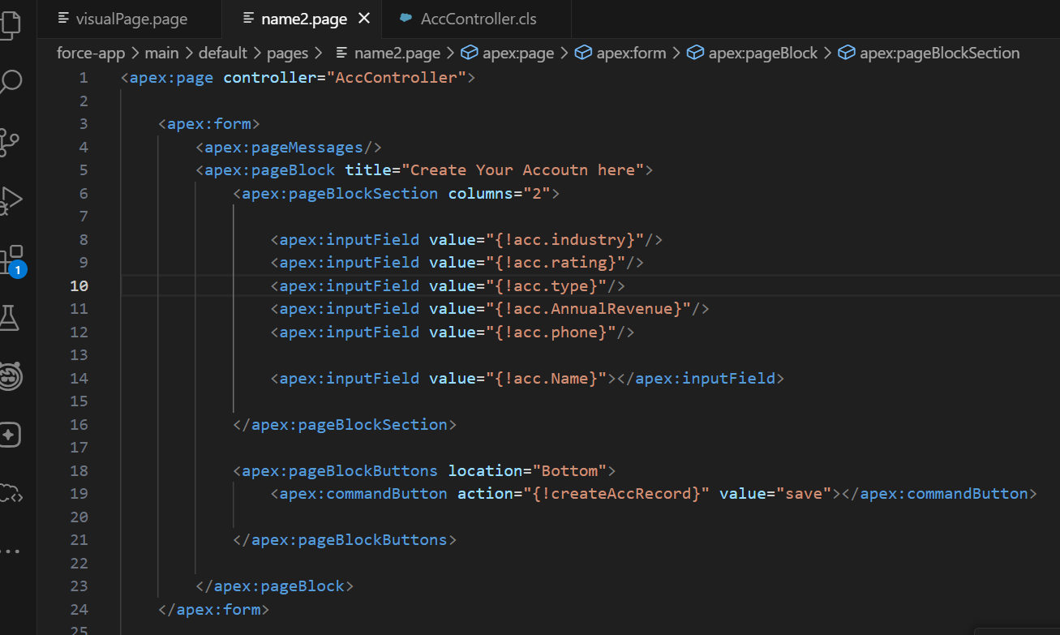

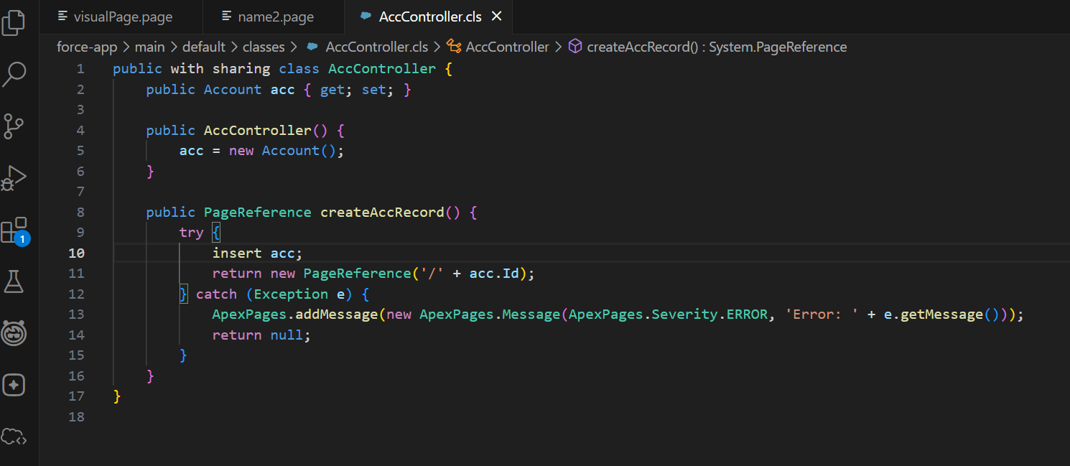

Extension :
- Prebuilt functionalities improve with extension
- We were not able to see from where the error message was coming—extend using extension
- No even by using standard controller, we can throw error
- 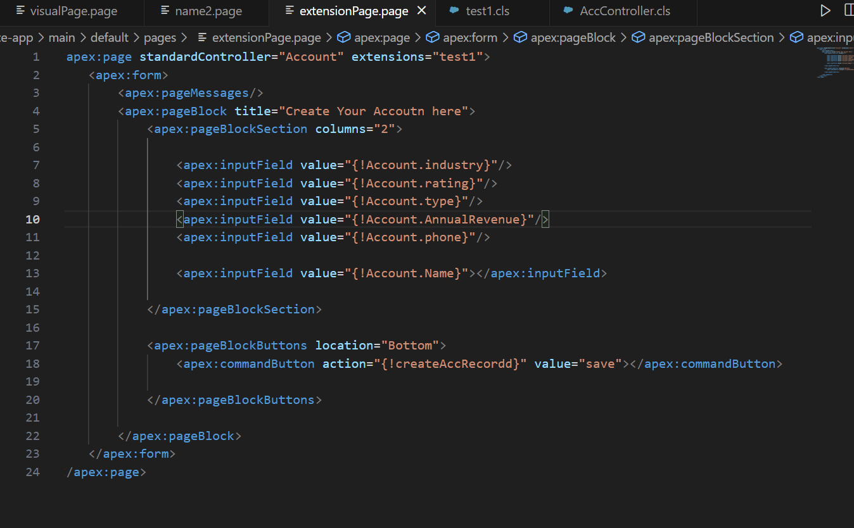
- 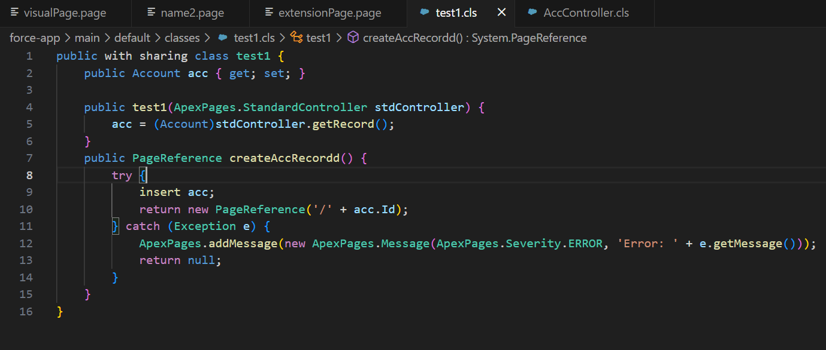

LWC :- HTML, CSS, JS

Javascript
- Scripting language used to write backend for web pages or used to make the collectivity between your database to your page
- Functions, return, var & let keyword,
- Arrow function -its application- set time out
- JSON – FUNCTION as json field
LWC can’t be done with the help of developer console.
- VS CODE
- LIGHTNING EXTENSION

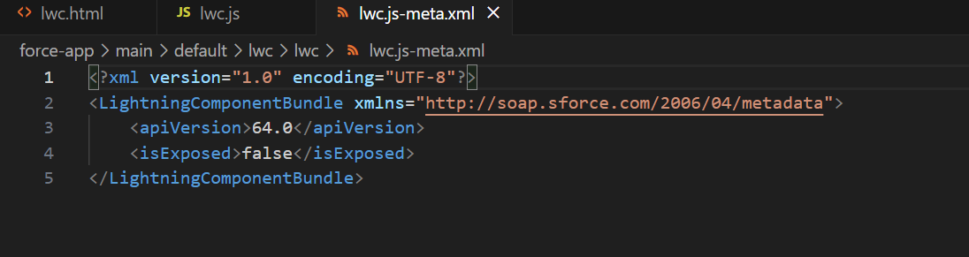

isExposed should be TRUE for v
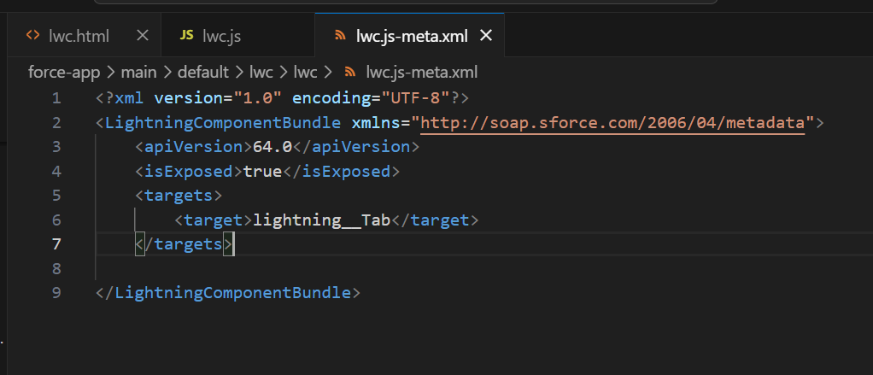

Here the code

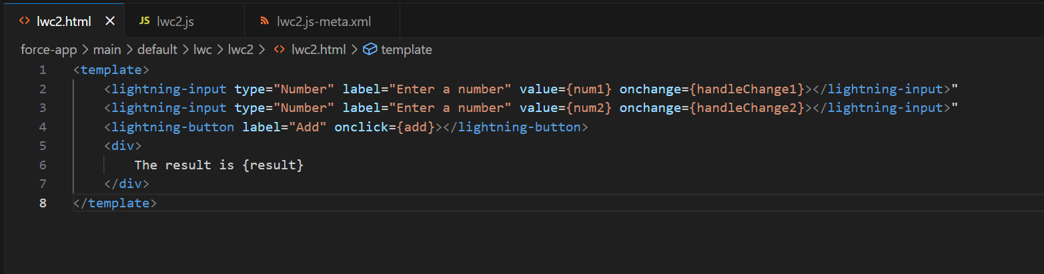
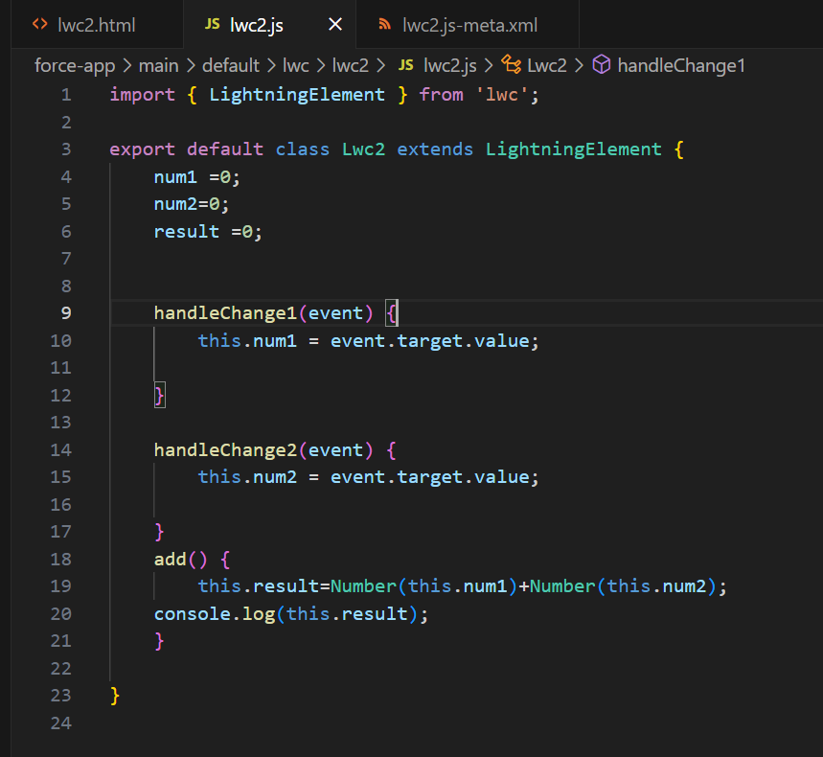
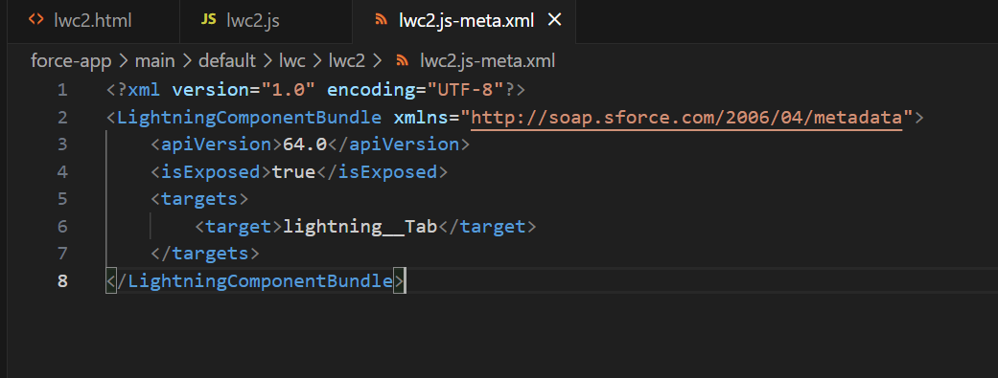

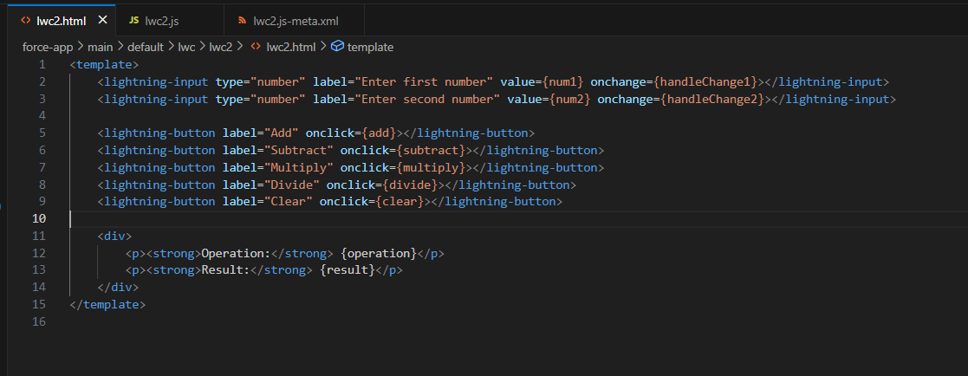
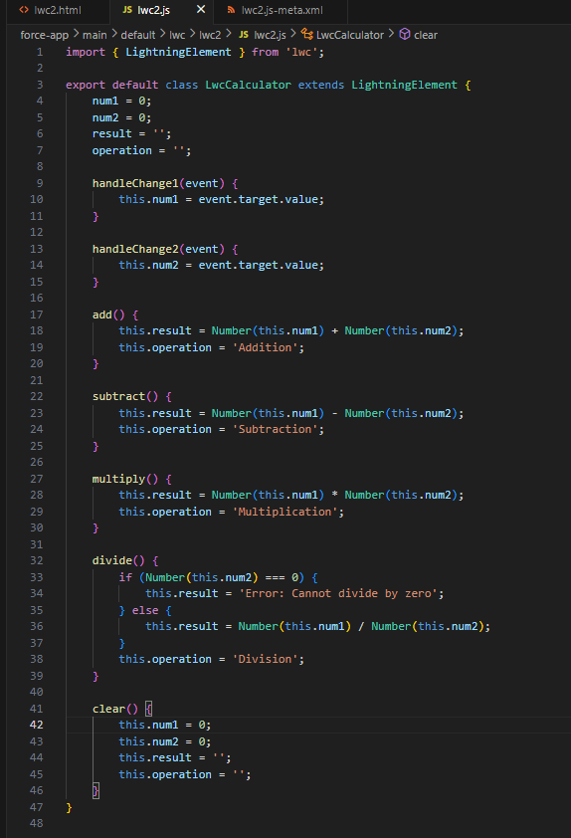
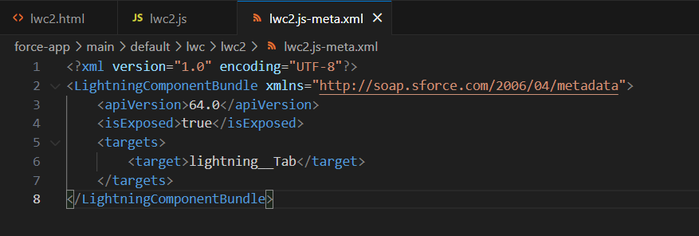
Other way
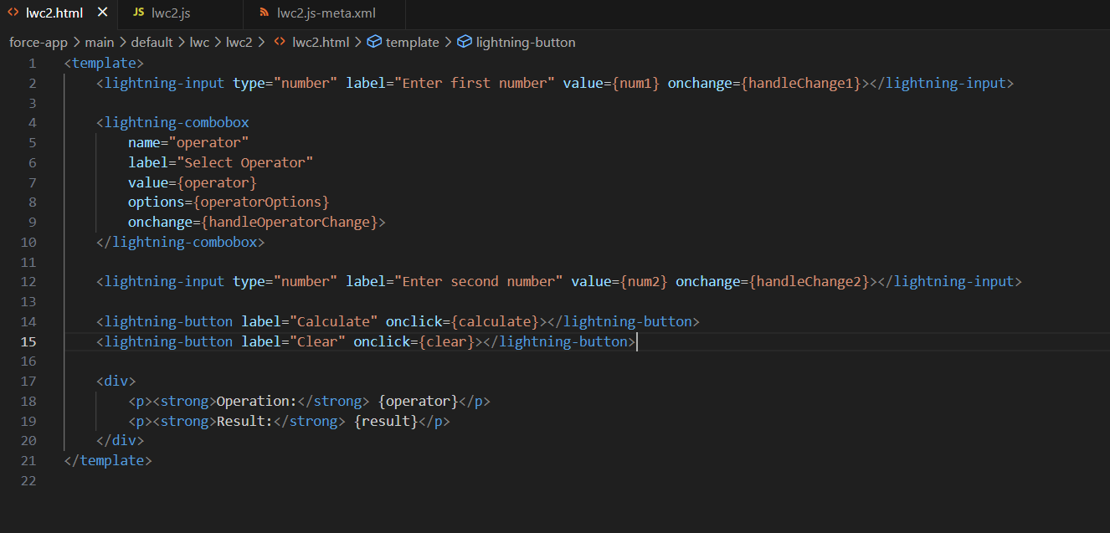

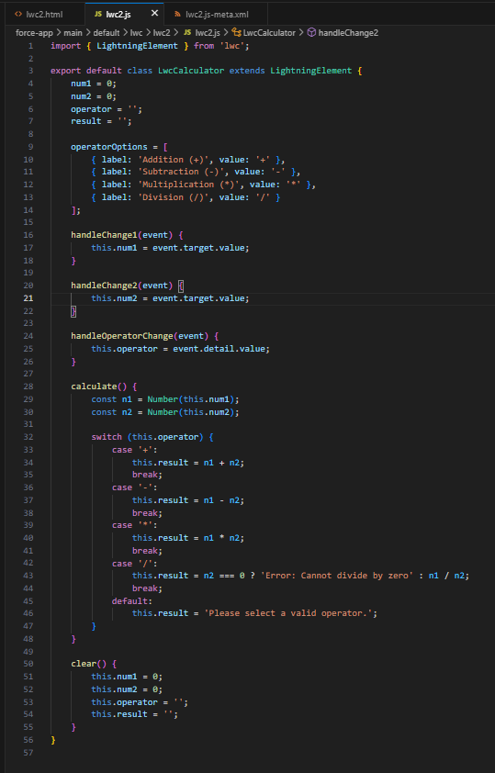
How to call a apex method from LWC

Two methods are available
- Imperative Mehod/ Promise Method
- Wire Method – as parameter and as method
@AuraEnabled is required to call apex for Imperative method

Wire as Method
- 